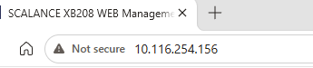

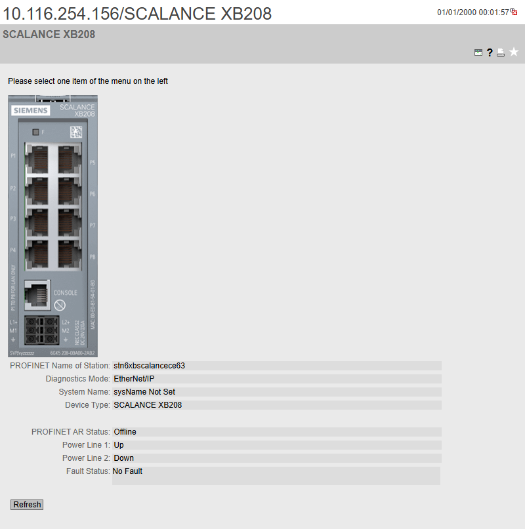

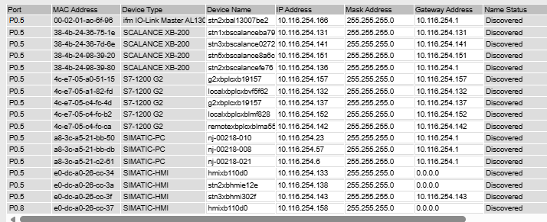
Some right but some wrong from the assigned IP’s.
Scalance XB-200: 10.116.254.156
S7-1200 G2: 10.116.254.157
Simatic-pc: 10.116.254.155
HMI: 10.116.254.158
Allen-Bradley: 10.116.254.212

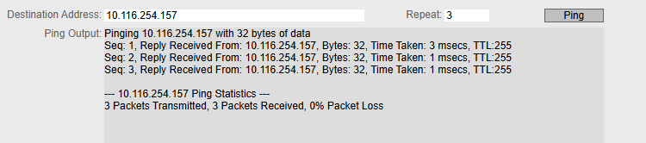
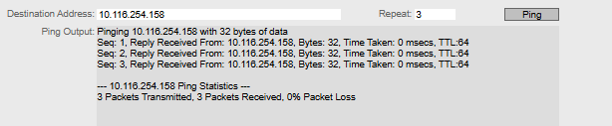

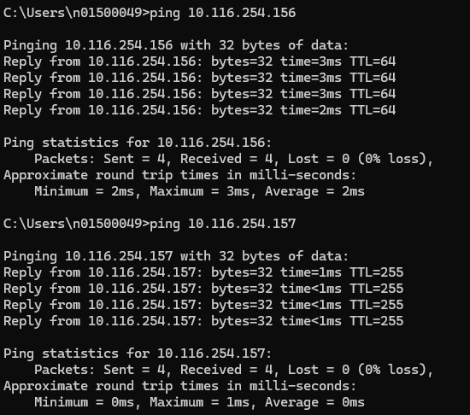
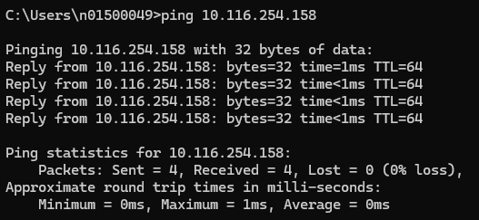
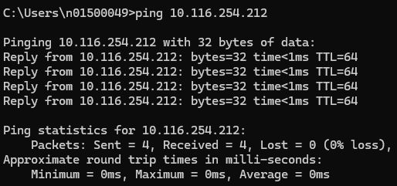

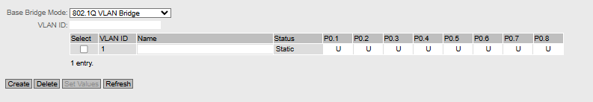

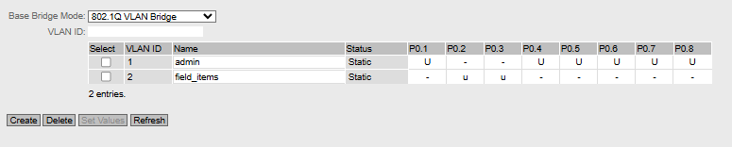

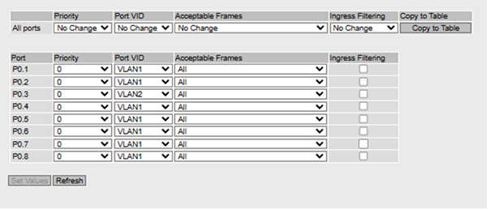

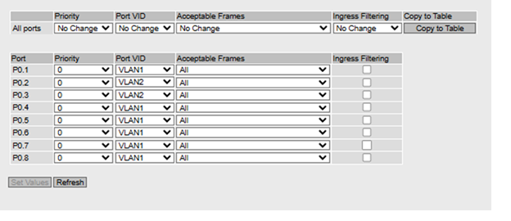

VLAN 1
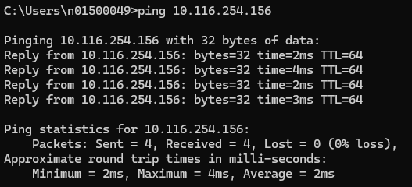
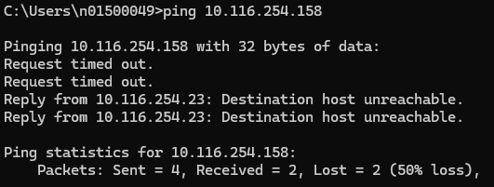

VLAN 2:
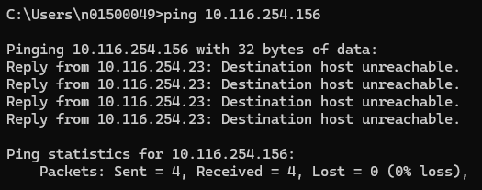
Vlan still had a connection on the report mention that there was an error to it and was able to connect.
Now this is the correct response for the vland2 where it doesn’t recognize it.
